3.import java.util.*;
public class Abc
{
public static void main (String[] args)
{
System.out.println("Author : J. GOPI VENKATA SAI\nSAP : 51834677");
int count=0;
int rem=0 ;
Scanner sc=new Scanner(System.in);
System.out.println("enter a number :");
int n= sc.nextInt();
while(n>0)
{
rem=n%10;
if(rem%2==0)
{
count++;
}
n=n/10;

}
System.out.println("no of even digits in n number are : "+count);

}
}

OUTPUT:
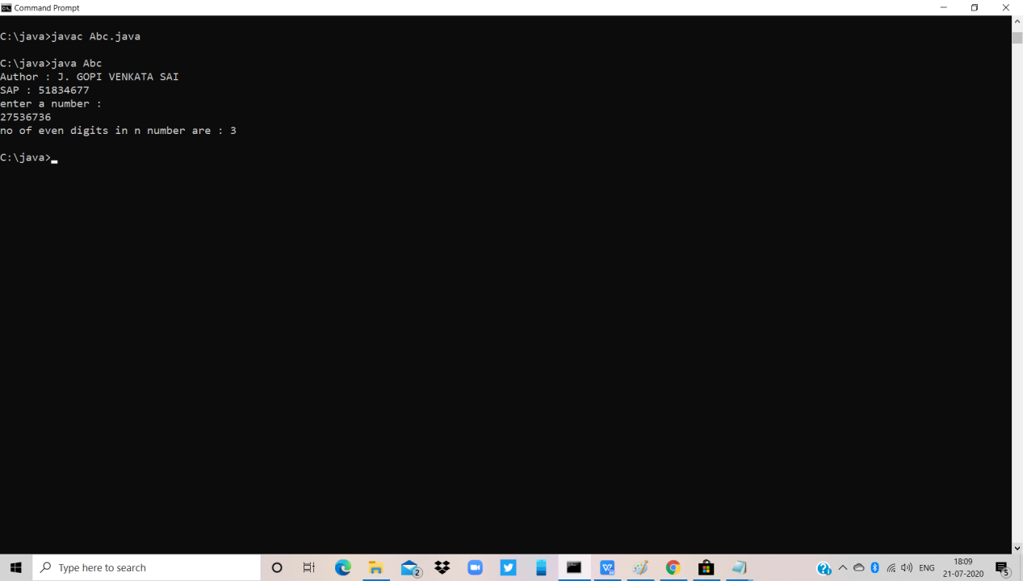

5.import java.util.Scanner;
class Dcoder
{
public static void main(String args[])
{
int k=0;
Scanner sc=new Scanner(System.in);
System.out.println("AUTHOR : J.GOPI VENKATA SAI\nSAP ID: 51834677");
System.out.println("Enter the size of array :");
int size=sc.nextInt();
while(size<1)
{
System.out.println("Enter a valid size : ");
size=sc.nextInt();
}
int arr[]=new int[size];
int arr2[]=new int[size];
System.out.println("Enter "+size+" elements :");
for(int i=0;i<size;i++)
{
arr[i]=sc.nextInt();
}
for(int i=0;i<size;i++)
{
int rev=0;
int temp=arr[i];
while(temp>0)
{
rev=rev*10+(temp%10);
temp=temp/10;
}
if(rev==arr[i])
{
arr2[k++]=arr[i];
for(int j=i;j<size-1;j++)
{
arr[j]=arr[j+1];
}
size--;
i--;
}
}
for(int i=0;i<size;i++)
{
System.out.print(arr[i]+" ");
}
System.out.print("\nPalindrome : ");
for(int i=0;i<k;i++)
{
System.out.print(arr2[i]+" ");
}
}
}

OUTPUT:
